Title
Author’s Name
Author’s email

Chapter Title (level 1)
This is a standard paragraph text. It uses Palatino font family, size 12 and is aligned justified, with the last paragraph line ending on the left. We have prepared a set of paragraph styles that make formatting easy. This style is called Contour Paragraph.
Article text should start with appropriate Heading (Chapter Title)
References section should be a numbered list (AMA - Vancouver citation style). This means that in-text citations should be pointed as [1], [2] or [3,4,5]. Please refer to the author and date of a source [1]. We strongly encourage authors to use a reference manager, such as Zotero.

Chapter Subtitle (level 2)
This is another paragraph. This style always appears following a title, subtitle or table and image captions.

Chapter Sub-subtitle (level 3)
In-text references for tables and figures are parsed if they mark as "tabl 1.", "table 1", "fig. 1", "figure". Tables should be referred to as:
Table 1: a brief description
Column title | Column title
Entry one left | Entry one right
Entry two left | Entry two right

In order to include a picture, write its caption as a normal paragraph (without using caption option) and insert the photo below using Insert... option in Microsoft Word after its caption.

Figure 1: Interpretation of the word "automagically"
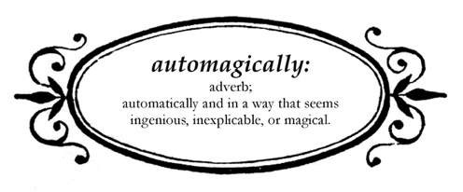
After which the text continues in normal paragraph style (Contour Paragraph).

References
- Treib, M. (1996). Space calculated in seconds: The Philips Pavilion, Le Corbusier, Edgard Varese. Princeton, N.J: Princeton University Press.

